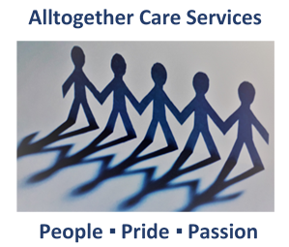

**Duty**

**of Candour Report**

**2021/2022**



All Health and Social Care Services in Scotland have a Duty of Candour. This is a legal requirement which means that when things go wrong and mistakes happen, the people affected understand what has happened, receive an apology, and that organisations learn how to improve for the future.

An important part of this duty is that we provide an Annual Report about the Duty of Candour in our services. This short report describes how our Care Service has operated the Duty of Candour during the time between 1st April 2021 and 31st March 2022.

**We hope you find this report useful.**

**INTRODUCTION**



1.1 Between 2021 /2022, there have been no incidents to which the Duty of Candour applied.

**1. How Many Incidents Happened To Which The Duty Of Candour Applies?**



2.1 Where something has happened that triggers the Duty of Candour, our Staff report this to the Care Manager who has the responsibility for ensuring that the Duty of Candour Procedure is followed.

2.2 The Care Manager records the incidents and reports as necessary to the Care Inspectorate. When an incident has happened, the Care Manager and Staff set up a learning review. This allows everyone involved to review what happened and identify changes for the future.

2.3 All new employees learn about the Duty of Candour at their induction. We know that serious mistakes can be distressing for staff as well as people who use care and their families. We will seek support for our staff if they have been affected by a Duty of Candour incident.

2.4 If you would like more information about our Home Care Services, please contact us:

**Alltogether Care Services**

**Head Office**

**Clydebank Business Park**

**Spectrum House, East Wing**

**1A North Avenue, Clydebank G81 2DR**

**Tel: 0141 952 9883**

**E-Mail: info@atcservices.co.uk**

**Website:**

[**https://www.alltogethercareservices.com/**](https://www.alltogethercareservices.com/)

**2. Information About Our Policies and Procedures**